ADTA 5560.701
Recurrent Neural Networks for Sequence Data
Assignment 5

PART I: RNN: LSTM: Core Concepts: Cell (C) State (50 Points)
SUBMISSION REQUIREMENT #1
--) Discuss the Cell (C) state of the LSTM neural network from two different points of views:
- A flow in a channel
- A snapshot of the cell state
Answer:
Introduction:
The cell state is the core component of the LSTM (Long short term memory) neural network. It carries information through the network, it also persists the information from the previous steps and updates the information as the network processes the data (sequential).

A flow in a channel
The below diagram shows an LSTM cell consisting of all major components.
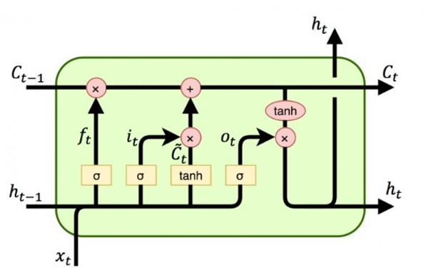
Figure: LSTM cell
Source: Course Material: ann_rnn_recurrent_neural_networks_LSTM_PART_II
The cell state is one of the key components of the LSTM. It is nothing but a horizontal line running through the top part of the cell with some minor interactions. The cell state can be considered as the steady state of the flow of information in the channel. It makes the flow of information easy when it is unchanged.
The diagram below shows the LSTM Cell with the flow in a channel.

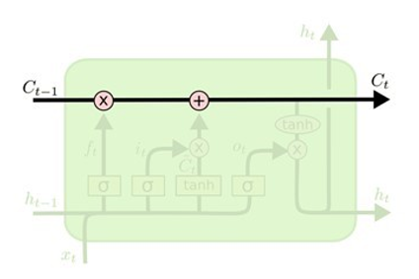
Figure: LSTM Cell flow in a Channel
Source: Course Material: ann_rnn_recurrent_neural_networks_LSTM_PART_II

The change of information can be accommodated through the gates.
Any later time step (or layer) can use information carried in from the previous Cell state without any reduction, if the information is still good, i.e., relevant and significant as there is no weight involved with the cell state that can stay as it is through multiple layers or time steps.
Being considered as an information transporting channel:
- Able to transfer information from the earliest time steps all the way to the end of the sequence chain.
- In theory, can carry relevant information throughout the processing of the sequence.
- Can mitigate the problem of short-term memory

A snapshot of the cell state
The diagram below shows the Cell (C) state of LSTM. It represents a snapshot of the learning of the model at a given timestep.

Figure: LSTM Cell state
Source: Course Material: ann_rnn_recurrent_neural_networks_LSTM_PART_II

The cell state can memorize the information in a cell at each step, no matter how early it is in the sequence.
Snapshot: A snapshot of the cell state can be represented as a static memory state at a particular point of time. The snapshot shows the current state of the memory before it flows into the next timestep.
State Representation: The cell state at a given timestamp is a vector which represents a memory unit with the information learned so far. It depicts the model’s learning at the given point of time. Each memory unit carries the values derived from the previous timestamps and current input. These are calculated based on the operations performed in the gates.
Conclusion:
In this section we discussed about the core concept of the Cell state which included a flow in a channel and a snapshot of the cell state.
PART II: RNN: LSTM: Core Concepts: Gates (50 Points)
SUBMISSION REQUIREMENT #2
--) Discuss why each gate in the LSTM neural network can be viewed as a neural network.
Answer:
Introduction:
LSTM uses a set of gates to protect and control the cell state and perform the required calculations.
There are total of three gates which include:
- Forget Gate
- Input Gate
- Output Gate
Each gate is a neural network that can learn to determine what information should be relevant or significant and then be used. Each gate can also be considered as a neural network layer. Each gate can learn to decide, during the training what information to keep because it is relevant and what information to “forget” because it is irrelevant or insignificant.
Forget Gate:
- Objective: To decide on what information to drop from the cell state.
- Input: Current input and previous hidden state.
- Activation Function: Sigmoid layer with output as 0 or 1. Where 0 stands for dropping the information and 1 for keeping the information.
- Operation:
ft=σ(Wf⋅[ht−1,xt]+bf)f_t = \sigma(W_f \cdot [h_{t-1}, x_t] + b_f)ft​=σ(Wf​⋅[ht−1​,xt​]+bf​)
  - WfW_fWf​: Weight matrix for the forget gate.
  - bfb_fbf​: Bias vector.
  - σ\sigmaσ: Sigmoid activation function.
- Resemblance with neural network: The forget gate applies a linear transformation (via WfW_fWf and bfb_fbf) followed by a nonlinear activation (σ\sigmaσ), which is characteristic of a neural network layer.
The diagram below shows the forget gate of the LSTM and the mathematical representation of the same.

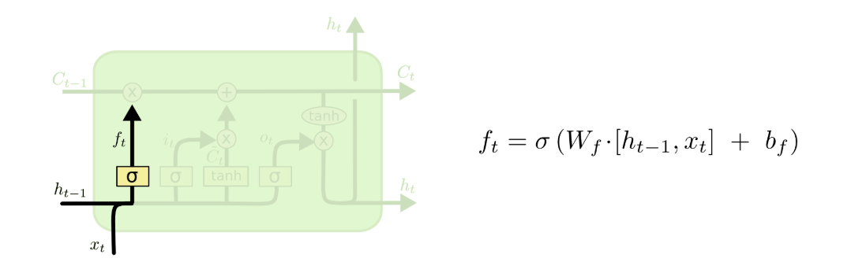
Figure: Forget Gate of LSTM Cell
Source: https://colah.github.io/posts/2015-08-Understanding-LSTMs/
Input Gate:
- Objective: To decide which new information to store in the cell state. It has two parts, a sigmoid layer which decides which value will be updated. A tanh layer which creates the vector to be updated. The old cell is updated with the new cell, i.e. the cell is updated with the newly calculated information.
- Input: Current input and previous hidden state.
- Activation Function: sigmoid and tanh
- Operation:
  - Decide which values to update.
  - Create a candidate for new information.
- Resemblance with neural network: Like the forget gate, it uses weights, biases, and a nonlinear activation. It uses a different set of weights, biases and activation function like the neural network operations.
The diagram below shows the input gate of the LSTM and the mathematical representation of the same.

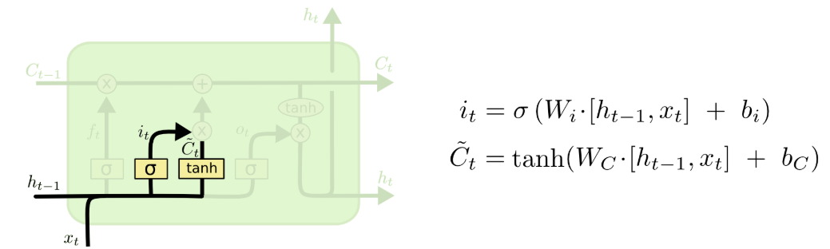
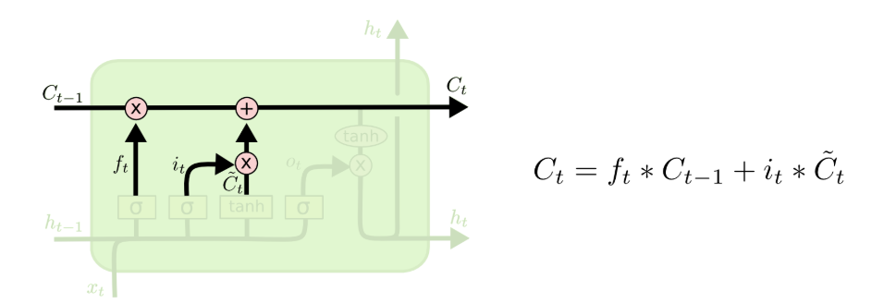
Figure: Input Gate of LSTM Cell
Source: https://colah.github.io/posts/2015-08-Understanding-LSTMs/

Output Gate:
- Objective: To identify which part of the cell to output. This output will be the hidden input to the next step. Initially, a sigmoid layer applied to a to determine which parts of the cell state will be output. Next, the cell state is passed through a tanh function (to constrain the values between −1 and 1) and then multiplied by the sigmoid gate's output, ensuring that only the selected parts are output.
- Input: Current input and previous hidden state.
- Activation Function: sigmoid and tanh.
- Operation: The hidden state is updated.
- Resemblance with neural network: Like the forget gate, it uses weights, biases, and a nonlinear activation. It uses a different set of weights, biases and activation function like the neural network operations.
The diagram below shows the input gate of the LSTM and the mathematical representation of the same.
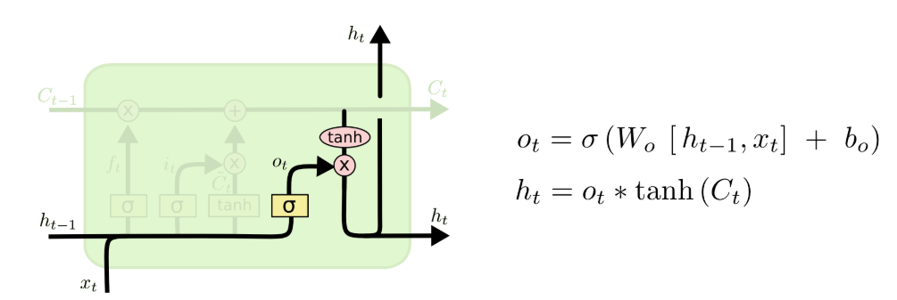
Figure: Output Gate of LSTM Cell
Source: https://colah.github.io/posts/2015-08-Understanding-LSTMs/
Conclusion:
In this section we discussed about the core concept of the Gates in LSTM and discussed about each of the gate in detail.

References:
Understanding LSTM Networks -- colah's blog
https://towardsdatascience.com/illustrated-guide-to-lstms-and-gru-s-a-step-by-step-explanation-44e9eb85bf21
Course Material: ann_rnn_recurrent_neural_networks_LSTM_PART_I
Course Material: ann_rnn_recurrent_neural_networks_LSTM_PART_II
Course Material: ann_rnn_recurrent_neural_networks_LSTM_PART_III

